Directions: The goal of the following problems is to help challenge and deepen your understanding of the current topic. Don’t assume that you will know how to answer each and every question. You will work with at least two other students in the class to try and find solutions and write arguments for each of the following questions. Be sure that you question your classmates’ reasoning. If you don’t understand how they are getting something you should ASK THEM TO EXPLAIN! Being able to defend your reasoning is important and so you are actually helping them by asking them to explain.

Challenge Questions
- Determine the equation of the line tangent to the curve at .

We see that .
Point:
Slope:

Therefore, the equation of the tangent line is .

- Determine all values of x where has tangent lines parallel to the line .

We see that
We want to have tangent lines parallel to which means that we want the tangents to have a slope of 7.

So, we want to find all values of x for which.

- Determine the equation of the line tangent to the curve at .

We see that .
Point:
Slope:

Therefore, the equation of the tangent line is .

- Determine all values of x where has tangent lines perpendicular to the line .

We see that
We want to have tangent lines perpendicular to which means that we want the tangents to have a slope of +2.

So, we want to find all values of x for which.

We would then proceed using the Quadratic Formula, but we note that and so this equation has no solutions.

Therefore, the given function never has a tangent line of slope 2.

- Find conditions on a, b, c, & d so that the graph of the polynomial has…
- exactly two horizontal tangents.
- exactly one horizontal tangent.
- no horizontal tangents.

We first calculate that .
If we want horizontal asymptotes you need to have .
We solve for x using the Quadratic Formula.
.
Depending on the value of there will either be 0, 1, or 2 values of x that make .
If then f will have two horizontal asymptotes.
If then f will have one horizontal asymptotes.
If then f will have no horizontal asymptotes.
d can have any value in all three cases.

- Find k if the curve is tangent to the line .

Let’s suppose that is tangent to the curve at .
This means that . So, since , this implies that .

Note then that when
and .

The equation of the tangent line at would then be

In order for this tangent line to be equal to we must have

- Find all values of a such that the curves and intersect at right angles.

We first want to find all intersection points of the curve.

Then we want the slopes of the tangent lines at these points to be opposite reciprocals.

Curves intersect when
Note that and . Therefore, the curves have slopes with opposite reciprocal tangent lines when
We note that isn’t a possible value that we can use here since the first curve isn’t even defined at

So, we need to determine all values of a for which and .

This means that we need
So, we have possible values of a of .
If we test these values to see if the lines are indeed opposite reciprocal slopes we find
- implies that and therefore the slopes of the tangent lines for each graph areand . These values are not opposite reciprocals and so doesn’t work.

- implies that and therefore the slopes of the tangent lines for each graph areand respectively. These values are opposite reciprocals and so does work.
- implies that and therefore the slopes of the tangent lines for each graph areand respectively. These values are opposite reciprocals and so does work.
- The segment of any tangent line to the graph of that is cut off by the coordinate axes is bisected by the point of tangency.

- Show this works for when .
We calculate that .

We make a tangent line at .
Tangent line: (with as the point of tangency)

This line has intercepts of and
The length of this line (between the axes) is given by the distance between .
The distance from either of these points to the point of tangency is
We can clearly see this is half the distance.

- Show this works for when .

We make an arbitrary tangent line at .
Tangent line: (with as the point of tangency)

This line has intercepts of and
The length of this line (between the axes) is given by the distance between .
The distance from either of these points to the point of tangency is
We can clearly see this is half the distance.

- Suppose that the function f is differentiable everywhere and that .
- Express a formula for in terms of x and derivatives of f.

Note that .
Note that .

- Express a formula for in terms of x and derivatives of f.

.

- For, conjecture of formula for .

We suspect that .

- Consider the polynomial functions , , and , where represent real numbers.
- Find , , and .

We calculate:
and
, , and
, , , and

- If n represents the degree of the polynomial, then what is the -st derivative of any polynomial? Why?

Based on our work in part (a) it appears that the -st derivative of a polynomial of degree n would be equal to 0. This is because computing the nth derivative fully decreasing the leading terms power on x to 0, leaving only a constant and then the -st derivative results in 0.

- Newton’s Law of Universal Gravitation states that the magnitude F of the force exerted by a point with mass M on a point with mass m is where G is a constant and r is the distance between the bodies. Assuming that the points are moving, find a formula for the instantaneous rate of change of F with respect to r.

We need to understand that we should trat G, m, & M as constants.
Note that and then .

- Show that if exists for each x in , then is continuous on .

If exists for all x-values in then this means that is differentiable on .
If is differentiable on , then it must be continuous on .

- The following graph depicts the position of two racers.
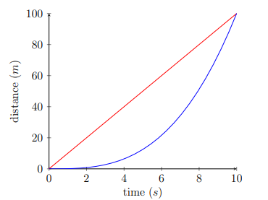
- Which racer has a faster average speed? When was each racer running faster than the other (approximately)? Which racer was running fastest at the end of the race?

The average speed of each racer is determined by the secant line between the endpoints. As such, the average speed of both racers is the same.

The red racer is running faster up until about or (this is when the slope of the tangent lines between the red and blue curves are roughly the same). After or it appears that the Blue racer was running fastest at the end of the race. This can be seen because the slope of the tangent line near is much steeper on the blue curve rather than on the red curve.

- On a separate plot from this picture, sketch the graphs of the velocities of these racers.

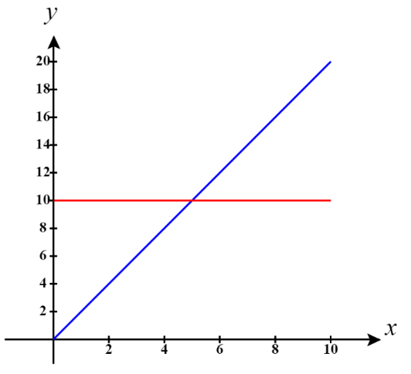

- Suppose that the distance (from the starting point) of the red racer is given by the function and the distance of the blue racer is given by . Suppose that & . Use this new information (and your knowledge of derivatives) to check whether your answers in parts (a) and (b) were accurate.

& .
This means that and which do resemble the functions that we have sketched in part (b).
These functions are also in line with the window of time from to where the velocity of the racers are supposed to be the same. Specifically, we can see that the velocities of the racers are equal when .

